Assessment Schedule – 2014

Physics: Demonstrate understanding of aspects of heat (90939)

Evidence Statement
Question | Achievement | Merit | Excellence
ONE  (a) | A vacuum between the containers reduces the heat loss by:  conduction  OR convection  OR acts as an insulator. | A vacuum between the containers reduces the heat loss by conduction AND convection, because both heat transfer methods require a medium to transfer heat energy.
(b) | Silvered surfaces reduce heat loss by radiation.  OR  Silvered surfaces reduce heat loss by reflection. | Silvered surfaces reduce heat loss by radiation because silver is a poor radiator of heat.  OR  Silvered surfaces reduce heat loss by reflection because silver is a good reflector of heat.
(c) | (i) Calculated the heat energy required correctly.  Amount of heat required to melt the ice is Q = m L  = 1.2 × 3.36 × 10⁵  = 403 200 J  OR  Calculates rate of heat gained correctly using an incorrect value for Q | (i) Amount of heat required to melt the ice is Q = m L  = 1.2 × 3.36 × 10⁵  = 403 200 J  11.6 hours = 11.6 × 60 × 60  = 41 760 s  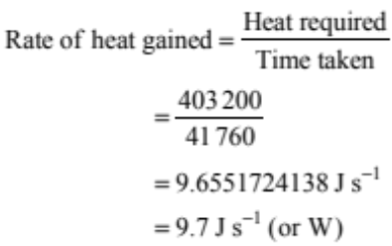  (Correct SI units required)  (Final answer can be to any number of s.f but must be correctly rounded) | (i)Amount of heat required to melt the ice is Q = m L  = 1.2 × 3.36 × 10⁵  = 403 200 J  11.6 hours = 11.6 × 60 × 60  = 41 760 s  (Correct SI units required)  (Final answer can be to any number of s.f but must be correctly rounded)
 | OR  (ii)Temperature difference between the water and the surroundings gets smaller. | OR  (ii) Temperature difference between the water and the surroundings gets smaller therefore the rate of gain of heat decreases. | AND  (ii) Temperature difference between the water and the surroundings gets smaller therefore the rate of gain of heat decreases.

(d)(i) |  | The top of the flask prevents heat loss by at least one of:  Convection  Evaporation  Conduction  Radiation. |  |  | The top of the flask prevents heat loss by at least one of:  Convection  Evaporation  Conduction  Radiation.  AND that mechanism is explained to show how this heat transfer / one part of a series of heat transfers reduces the temperature of the water  Eg:  If the top is not covered, water conducts heat to the air and hot air rises as it is less dense than the cold air outside the flask, and heat is lost by convection. This convection eventually cools the contents of the flask. |  |  |  | The top of the flask prevents heat loss by at least one of:  Convection  Evaporation  Conduction  Radiation.  AND that mechanism is explained to show how this heat transfer / one part of a series of heat transfers reduces the temperature of the water  Eg:  If the top is not covered, water conducts heat to the air and hot air rises as it is less dense than the cold air outside the flask, and heat is lost by convection. This convection eventually cools the contents of the flask.
(ii) |  | OR  Heat will escape by conduction through the cap.  OR  Heat is lost by radiation through the walls of the vacuum. |  |  | OR  Heat can escape by conduction through the cap because it is not a perfect insulator.  OR  Heat is lost by radiation through the walls of the vacuum because the mirrors are not perfect. |  |  |  | AND  Heat can escape by conduction through the cap because it is not a perfect insulator.  OR  Heat is lost by radiation through the walls of the vacuum because the mirrors are not perfect.
NØ | N1 |  | N2 | A3 |  | A4 | M5 | M6 |  | E7 | E8
No response or no relevant evidence | 1a |  | 2a | 3a |  | 4a | 2m | 3m |  | 1e | 2e

Question | Achievement | Merit | Excellence
TWO  (a) | 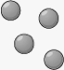  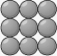  solid steam  OR  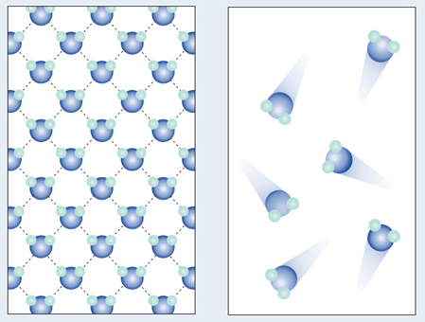  Both diagrams are correct.  Solid must have the regular arrangement, while steam particles are randomly dispersed.  (Consistent particle size in each box not required.)
(b)(i) | The particles in the metal body vibrate more when heated. | The particles in the metal body gain heat and they begin to vibrate more when heated taking up more space / loosening the bonds. This causes the saucepan to expand. | The particles in the metal body gain heat and they begin to vibrate more when heated taking up more space / loosening the bonds. This causes the saucepan to expand.
(ii) | OR  Latent Heat or Energy is needed to separate the particles. | OR  Latent Heat or Energy is needed to separate the particles. (The bonding between the particles in water is stronger and) energy is needed to overcome the force of bonding and to separate the water into steam particles. | AND  Latent Heat or Energy is needed to separate the particles. (The bonding between the particles in water is stronger and) energy is needed to overcome the force of bonding and to separate the water into steam particles.

(c)(i) | In both water and steam, the particles are free to move about / can form convection currents  OR  Particles take the shape of the container (no fixed shape) | In both water and steam, the particles are free to move about / can form convection currents.  OR  Particles take the shape of the container (no fixed shape)
(ii) | OR  The bonding of the particles in steam is weaker than that in liquid (water).  OR  Particles in steam have more energy than those in water.  OR  Particles are closer together in water than in a gas. | AND  The bonding of the particles in steam is weaker than that in liquid (water).  OR  There are bonds between the liquid particles and no bonds between the gas particles. Particles in steam have more energy than those in water.  OR  Particles are closer together in water than in a gas.  OR  Gas Particles moving quicker / have more kinetic energy than liquid particles.
(d) | Correct method for one calculation.  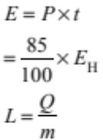  Eg:  - Calculated the heat energy given out by the heater in 35 s (5250 J).  - Calculated the heat energy given to the liquid in 35 s (4462.5 J).  - Incorrectly calculates the heat energy given to the liquid in 35s but calculates 85% of that value correctly. | ONE correct calculation  AND  One correct method for one of the other two calculations.  Eg:  - Calculated the heat energy given out by the heater in 35 s (5250 J).  - Calculated the heat energy given to the liquid in 35 s (4462.5 J).  - Incorrectly calculates the heat energy given to the liquid in 35 s.  OR  All three calculations correct with answer of 595 000 (with no unit / incorrect unit / incorrect rounding). | All THREE calculations correct  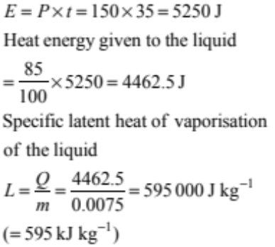  (Correct SI units required)  (Final answer can be to any number of s.f but must be correctly rounded)

NØ | N1 | N2 | A3 | A4 | M5 | M6 | E7 | E8
No response or no relevant evidence | 1a | 2a | 3a | 4a | 2m | 3m | 1e | 2e

Question | Achievement | Merit | Excellence
THREE  (a) | Radiation. | Radiation.  AND  The energy travels in the form of waves / electromagnetic rays / do not require a medium to travel.
(b) | ONE correct statement is given Eg:  - Some energy is reflected away by the water.  - Some energy is absorbed by the mirror.  - Some energy is absorbed by the metal tank. | - TWO correct statements with at least one correct reason given. Eg:  - Some energy is reflected away by the water because water can reflect light as well as absorb it / water can act like a mirror.  - Some energy is absorbed by the mirror because mirrors cannot reflect all the light that shines on them (some light is always absorbed).  - Some energy is absorbed by the metal tank because metal is a good absorber of heat / conducts heat away. | TWO correct statements with TWO correct reasons given. Eg:  - Some energy is reflected away by the water because water can reflect light as well as absorb it / water can act like a mirror.  - Some energy is absorbed by the mirror because mirrors cannot reflect all the light that shines on them (some light is always absorbed).  - Some energy is absorbed by the metal tank because metal is a good absorber of heat / conducts heat away.
(c) | Correct method for ONE calculation.  E = 630 × 1.5  Q = mcΔT  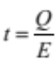  Eg:  Energy supplied by the mirror per second is calculated.  OR  The amount of heat required to heat the water is calculated. | ONE correct calculation.  AND  One correct method for one of the other two calculations.  Energy supplied by the mirror per second and the amount of heat required to heat the water is calculated.  All three calculations correct with answer of 1422 (with no unit / incorrect unit / incorrect rounding) or 23.7 minutes | All THREE calculations correct:  Energy supplied by the mirror per second = 630 × 1.5 = 945 J.  Amount of heat required  Q = mcΔT  = 5.0 × 4200 × (90 – 26)  = 1 344 000 J or 1344 kJ  Minimum time taken  = 1344 000 / 945  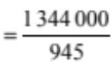  = 1422 to 1423 s  (with no unit / incorrect unit / incorrect rounding)

(d) |  | States at least TWO modifications. Eg:  - Wrap the tank with a non-conductor of heat / put on non-conducting base.  - Paint the inside of the tank black or paint all the tank black (all the exposed sides can absorb radiation)  - Cover the tank with a glass / transparent material  - Paint bottom of the tank with silver / white paint.  - Make mirror larger surface area (but not focus mirror more) |  |  | States and explains ONE modification. Eg:  - Wrap the tank with a non-conductor of heat. This will reduce the heat loss by conduction and convection.  - Paint the inside of the tank black OR paint all the tank black (all the exposed sides can absorb radiation). Black is a good absorber of radiant energy, so that any heat radiated through the water would be absorbed / any direct sunlight would be absorbed by the black walls.  - Cover the tank with a glass / clear / transparent material. It traps the radiant energy / reduces the heat loss by convection.  - Paint bottom of the tank with silver / white paint. This will reduce the heat loss by radiation.  - Make mirror larger surface area so more light is incident on the water tank. |  |  |  | States and explains TWO modifications. Eg:  - Wrap the tank with a non-conductor of heat. This will reduce the heat loss by conduction and convection.  - Paint the inside of the tank black OR paint all the tank black (all the exposed sides can absorb radiation). Black is a good absorber of radiant energy, so that any heat radiated through the water would be absorbed / any direct sunlight would be absorbed by the black walls.  - Cover the tank with a glass / clear / transparent material. It traps the radiant energy / reduces the heat loss by convection.  - Paint bottom of the tank with silver / white paint. This will reduce the heat loss by radiation.  - Make mirror larger surface area so more light is incident on the water tank.
NØ | N1 |  | N2 | A3 |  | A4 | M5 | M6 |  | E7 | E8
No response or no relevant evidence | 1a |  | 2a | 3a |  | 4a | 2m | 3m |  | 2e | 3e

Cut Scores
 | Not Achieved | Achievement | Achievement with Merit | Achievement with Excellence
Score range | 0 – 7 | 8 – 14 | 15 – 19 | 20 – 24

